Beer, Wine and Coffee Sayings

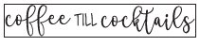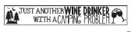
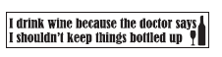
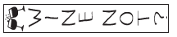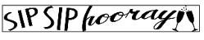
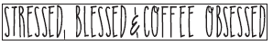

Camping and Outdoors
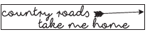
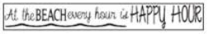
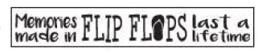

Home Sayings
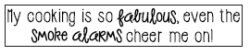
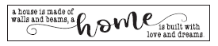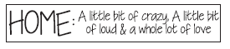
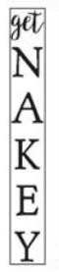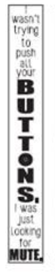
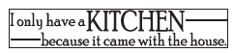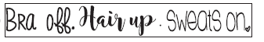
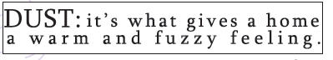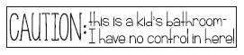

Family Sayings

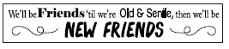
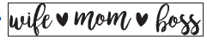
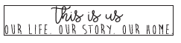
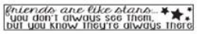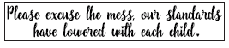
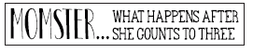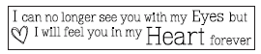
Please excuse the color on these – Vinyl comes in white and you choose the background color

Love Sayings
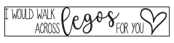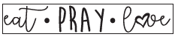
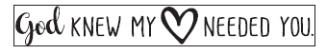

Pet Sayings
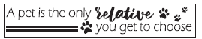
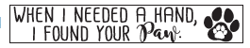
Inspiring Sayings
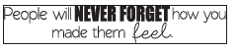
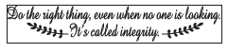
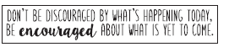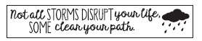
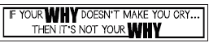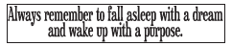
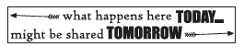
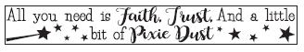
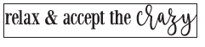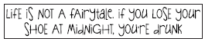
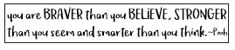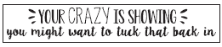
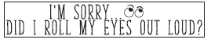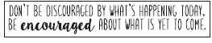
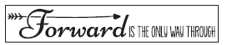
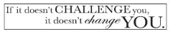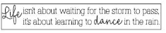

Spiritual Sayings
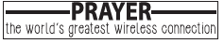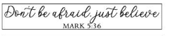
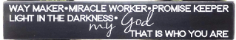
Please excuse the black background – Vinyl comes in white and you choose the paint color for background
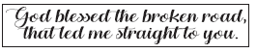
Fall Sayings
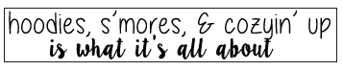
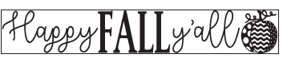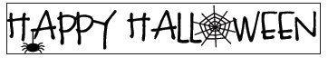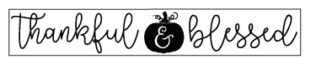
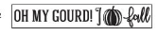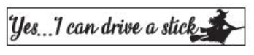
Please excuse the color on these – Vinyl comes in white and you choose the background color
Christmas Sayings

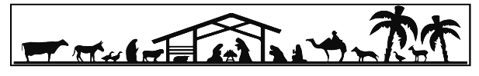
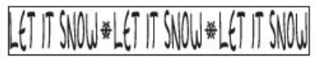
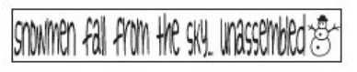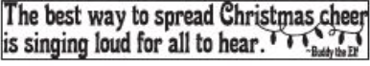
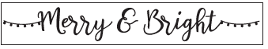
Please excuse the color on these – Vinyl comes in white and you choose the background color
